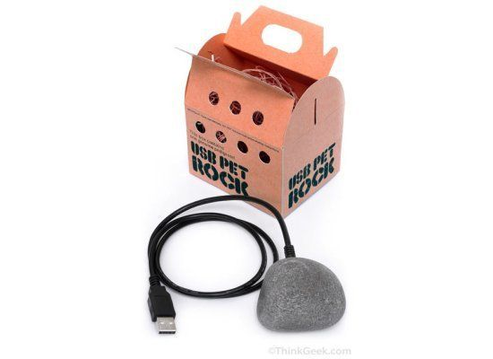 Yup it’s a pet rock. Simple to look after, doesn’t make a mess for you to clean, you don’t need to feed it, it doesn’t need affection and pampering and it does absolutely nothing. Each pet rock is completely unique. Plug it in to the USB port on your computer, and guess what!? It uses no power from your computer or laptop because the USB pet rock doesn’t do anything. Imagine how confused your friends will be. You can get one here for $29.99

Stressed? Have a headache?
Headtime, a gigantic silver helmet equipped with 29 silicon balls, 34 ceramic balls, and speakers, can supposedly help.
The scalp-massaging helmet from Kinatech promises to give your a robotic head message (with heat, if you'd like) and soothe you with the sound of birds chirping and waves crashing piped into your Headtime hat.

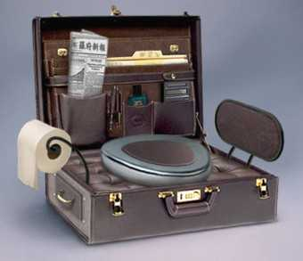

The briefcase toilet
This is a must-have for any business travelers who want to avoid the dodgy toilets at the airports.

The paper e-mail pad
Ever wanted to send an e-mail to someone that doesn’t have e-mail. Well here is the solution, just write them an e-mail on this pad and mail it the old fashioned way. Just remember to fill in the CC list, but the BC list is kind of tricky.
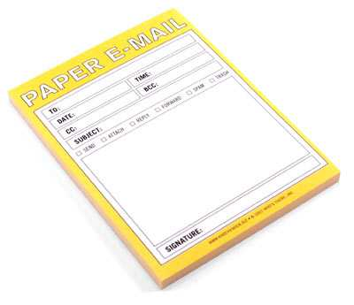
This pad will only cost you $3.99.

The Message Toaster
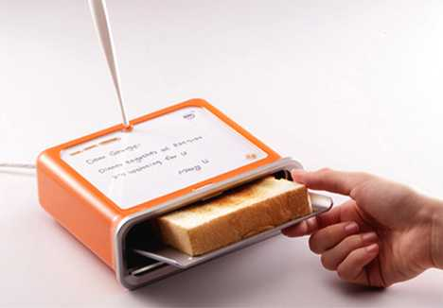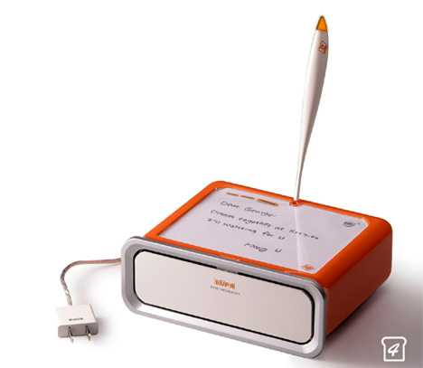Ever wanted to leave someone a message on their breakfast. Well now you can with the message toaster. You write the message on top of the toaster and it will toast your message in to the bread

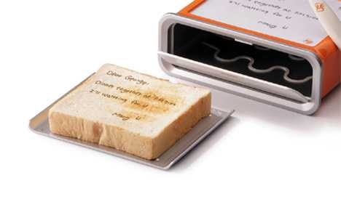

Pet Peek
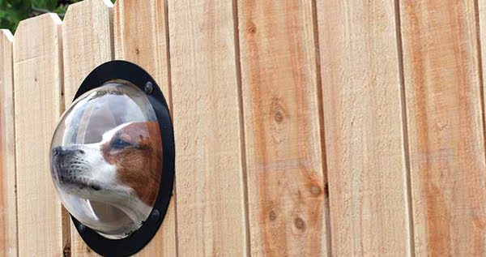

Dogs are curious, they want to know what's happening out there. Help satisfy there curiosity and make it possible for them to have a peek. A great addition to any fence.

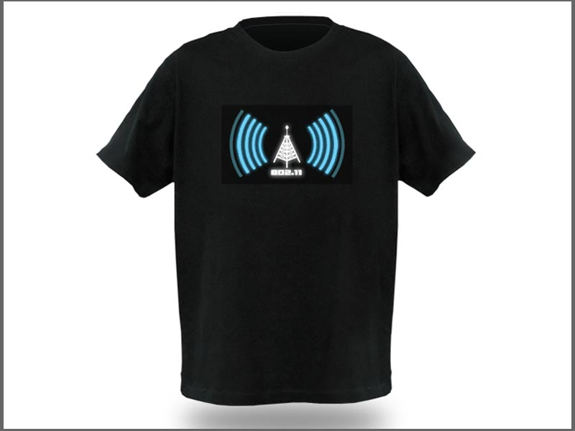WiFi Detector T-Shirt
This novelty WiFi Signal T-shirt glows up when you are in range of a WiFi signal, not only that it will show you how strong the signal is using the bars! The WiFi Tee shows signals for 802.11b or 802.11g frequencies and runs from AAA batteries, the t-shirt is plain black and the WiFi detector decal can be removed from the front when and if you want to wash the tee.
Made from 100% Cotton available in numerous sizes. Check it out below.
Or check:

https://www.designswan.com/archives/breakfast-easy-and-fun-12-innovative-kitchen-gadgets.html

http://wtfgadgets.com/

or simply google funny gadgets yourself.

