Students Killed by Gunman at Amish Schoolhouse

By John Holusha
Oct. 2, 2006
A lone gunman walked into a one-room schoolhouse in a largely Amish community in southeastern Pennsylvania today and shot as many as 10 girls, killing three immediately before turning the gun on himself and dying at the scene, according to the state police.
The man, identified as Charles Carl Roberts IV, 32, who lived in the area, was evidently nursing a long-ago grievance expressed in notes left for his wife and children, said Jeffrey Miller, commissioner of the state police. He said the gunman lined the girls against the blackboard, bound their feet and shot them execution-style in the head.
“He split them up, males and females," Commissioner Miller said. "He let the males go, some of the adults go. He bound the females at the blackboard, and apparently executed them."
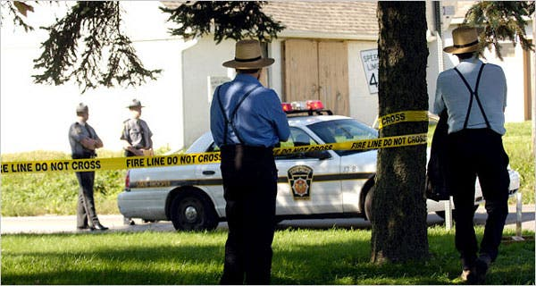
Image
Amish men standing near Pennsylvania State Police outside the scene of a school shooting today in Bart Township, Pa.Credit...Mike Mergen/Bloomberg News
Three of the girls were dead at the scene in Nickel Mines, Pa., and seven others were rushed to nearby hospitals, some of them severely wounded. An earlier Associated Press report quoted a local coroner as saying there were six people dead, but the coroner later said he was unsure, The A.P. said.
Commissioner Miller told CNN this evening that of the several victims who had been taken to hospitals, two of the girls were in “dire” condition and might not live.
“There was some issue in the past” that had left the gunman with a desire to harm female students, Commissioner Miller said. He said that the murders were premeditated and that the gunman had called his wife — without telling her he was holding hostages in a school — that he would not be coming home.
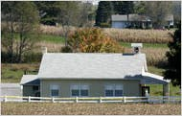
Image
The outside of the schoolhouse.Credit...Christopher Millette/The Harrisburg Patriot-News via Associated Press
Commissioner Miller said Mr. Roberts called his wife from a cell phone, saying he was "acting out in revenge for something that happened 20 years ago.”
"It seems as though he wanted to attack young, female victims," he said, according to The Associated Press.
The gunman released about 16 boys in the class, a pregnant teacher’s aide and three women with small children before the shooting, began, Commissioner Miller said. The principal teacher escaped at that time and ran to a nearby property to call 911.
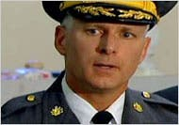
Image
Police Commissioner Jeffrey Miller.Credit...CNN
The gunman, who was not Amish, evidently chose the small, private Amish school in Lancaster County about 55 miles west of Philadelphia because the security would be lax, Commissioner Miller said. He said when police tried to talk to the gunman over loudspeakers to begin negotiations, Mr. Roberts made a cellphone call from inside the building threatening to start shooting unless police pulled back.
He was armed with an automatic pistol and a shotgun and had barricaded the doors to the school with structural lumber to slow down the police, who tried to charge in once the shooting started.
Police said the gunman worked as a truck driver who collected milk from nearby farms for processing and sale. Police said he walked his own children at a nearby bus stop before borrowing a relative’s pick-up truck and heading for the Amish school.
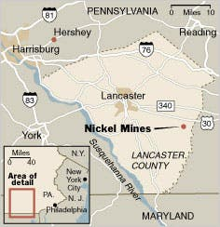
Image
The school is just outside Nickel Mines, a tiny village about 55 miles west of Philadelphia.
Commissioner Miller of the State Police said the gunman was not wanted for any crimes and apparently did not have a criminal record.
The shootings terrified this bucolic community of farmfields and small businesses.
“This is terrifying,” said Evelyn Vandament, who lives about a quarter of a mile from the school. “This happens in the city and other states, not in Amish country.”
Ms. Vandament, who is not herself Amish but sees them as her friends and good neighbors, consoled the parents of some of those in the school today.
“Oh, God, I just thought of my grandkids,” she said, in tears. “I cried with them, I prayed with them. It’s been a horrible experience.”
John Fisher, who owns a fencing company nearby, stood by the scene of the hostage situation, and also seemed stunned by the incongruity of the day’s events in this peaceful community.
“It makes you wonder what’s safe, where’s safe,” he said. “We’ve just got to pull together, help each other, breathe together, get through this.”
Maria Newman contributed reporting from New York and Gary Gately from NickelMines, Pa.

