Columbine High School Massacre

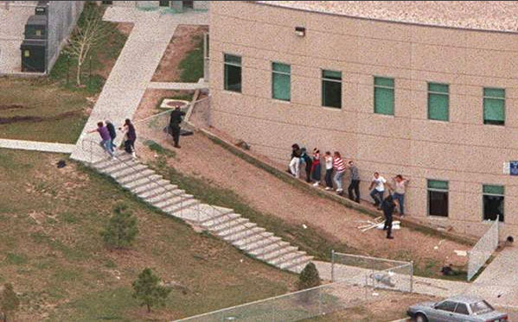  
Read the text at:

<http://en.wikipedia.org/wiki/National_Rifle_Association>



Your assignment is to make a PowerPoint presentation, which tells us about: the arms used in this incident, the Americans relations with arms and naturally about the NRA!

